- Find a popular blog in your favorite niche (e.g., tech gadgets, IPL cricket, travel, or fashion) and identify one website where you could pitch a guest post — write a short email draft (subject + 3-4 lines) proposing your article idea.
Guest Post Pitch – Travel Niche
I found Himalayan Destination, an Indian travel website that accepts travel guest-post pitches and publishes original travel stories.
Subject: Guest Post Idea – 7 Budget-Friendly Places to Visit in India
Email:
Hi Himalayan Destination Team,
I would like to contribute a guest post titled “7 Budget-Friendly Places to Visit in India.”
The article will provide practical tips on budget, travel, food, and accommodation for each destination.
I believe this would be useful for your readers and fit well with your travel content.
Thank you for considering my idea.
- Choose any 3 food delivery or e-commerce sites (like Zomato, Swiggy, Flipkart, Myntra) and use a free backlink checker tool (such as Ahrefs Free Backlink Checker or Ubersuggest) to list 2-3 websites that link to each. Note the type of content those backlinks point to (e.g., blog post, product page, resource list).
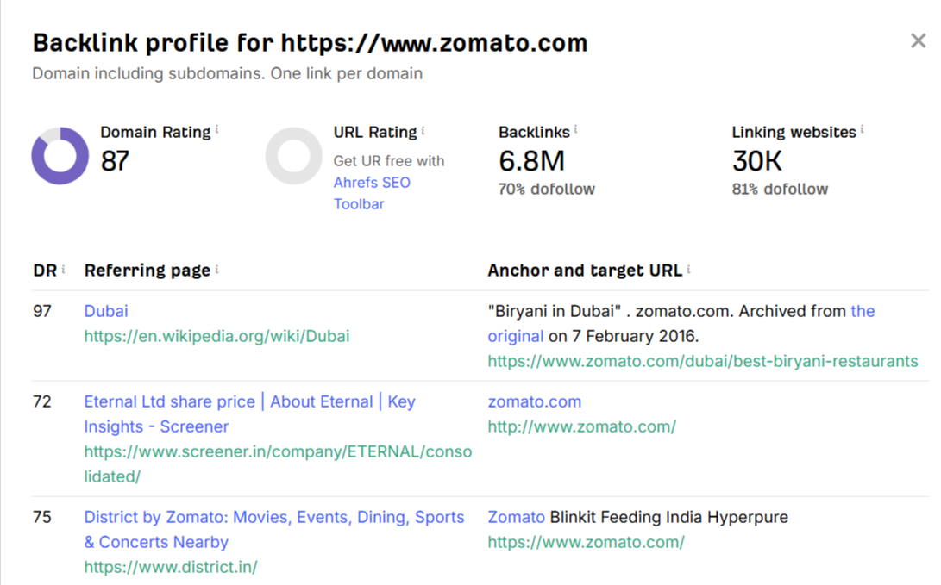

- Find a broken link on a real resource page (for example, a college department's 'useful links' page or a tech blog's tools list), and draft a message to the site owner suggesting your own relevant content as a replacement.<br><br><em><strong>Hint:</strong> Use Chrome's Check My Links extension or simply click through a few links to spot a 404.</em>

https://cec.nic.in/cec/
https://cec.nic.in/Pages/Home.aspx
Status: 404 Not Found when checked.
Broken Link on Your Library Useful Links Page
Hi,
I was browsing The American College Library's Useful Links page and noticed that the link listed for the Consortium for Educational Communication (CEC) appears to return a 404 error.
The broken link is:
http://cec.nic.in/Pages/Home.aspx
I thought I'd let you know so your team can update or replace the link when convenient.
I also have a relevant educational resource that could potentially serve as a replacement: [Your Content URL]
Thank you for maintaining such a useful resource page for students and researchers.
Best regards,
[Your Name]

- Pick an existing blog post or article from any site and apply the Skyscraper technique: suggest 2 ways to make the content more valuable or comprehensive than the original, and describe how you would promote your improved version to get backlinks.
Original article: HubSpot – “Blog SEO: How to Search Engine Optimize Your Blog Content”
Topic: Blog SEO

2 ways I would make it better:
- Add practical examples and screenshots
Show exactly how to optimize a blog title, URL, headings, meta description, images, and internal links with real examples.
- Add an updated SEO checklist + case study
Include a downloadable checklist and a small case study showing how traffic/rankings changed after applying the techniques. This makes the content more actionable and link-worthy.

How I would promote it for backlinks:
- Find websites that already link to similar blog SEO guides using Ahrefs or Semrush.
- Contact those website owners and explain that I created a more detailed and practical updated guide.
- Share the guide with SEO communities, LinkedIn groups, Reddit discussions, and relevant marketing newsletters.
- Contact SEO bloggers and educational websites and suggest my guide as an additional resource.
- Promote the checklist/case study because original, useful resources give people a stronger reason to link.
- Sign up for a free account on Featured.com, Qwoted, or Help a B2B Writer, and submit a response to a relevant journalist's query (it can be a draft, no need to actually send). Paste your draft pitch and explain why your answer would be attractive for the journalist to include.

Qwoted Journalist Pitch – SEO Mistakes in 2026
Hi
One of the biggest SEO mistakes businesses make in 2026 is focusing only on keywords instead of the actual search intent behind those keywords.
I would highlight three common mistakes:
- Creating content just to target keywords: A page can rank poorly if it doesn't actually answer what the searcher wants. Businesses should identify the intent—informational, commercial, or transactional—before creating content.
- Ignoring technical SEO: Slow page speed, poor mobile usability, broken internal links, and indexing problems can prevent otherwise good content from performing well.
- Not updating existing content: Businesses often keep publishing new articles while older pages become outdated. Regularly updating statistics, examples, links, and search-intent alignment can make existing content more useful and competitive.
My key takeaway for businesses is: “SEO in 2026 is not just about getting a page indexed; it is about making that page the most useful result for the searcher.”
I’d be happy to provide additional insights on SEO, content strategy, and digital marketing if useful for your article.
Best,
Disha Prajapati
Digital Marketing / SEO

